11.71: a) Consider the forces on the roof
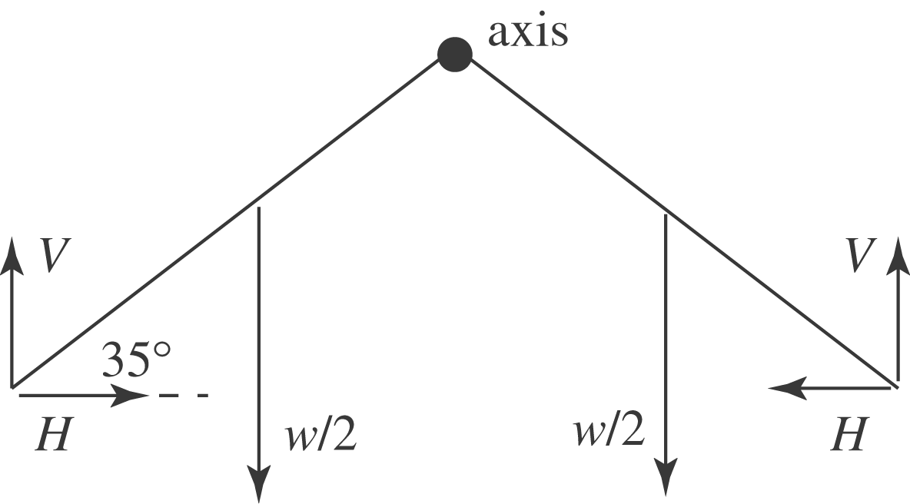

V and H are the vertical and horizontal forces each wall exerts on the roof.
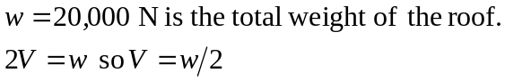
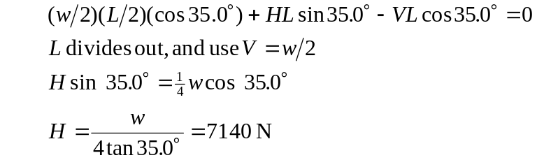
By Newton’s 3rd law, the roof exerts a horizontal, outward force on the wall. For torque about an axis at the lower end of the wall, at the ground, this force has a larger moment arm and hence larger torque the taller the walls.
b)

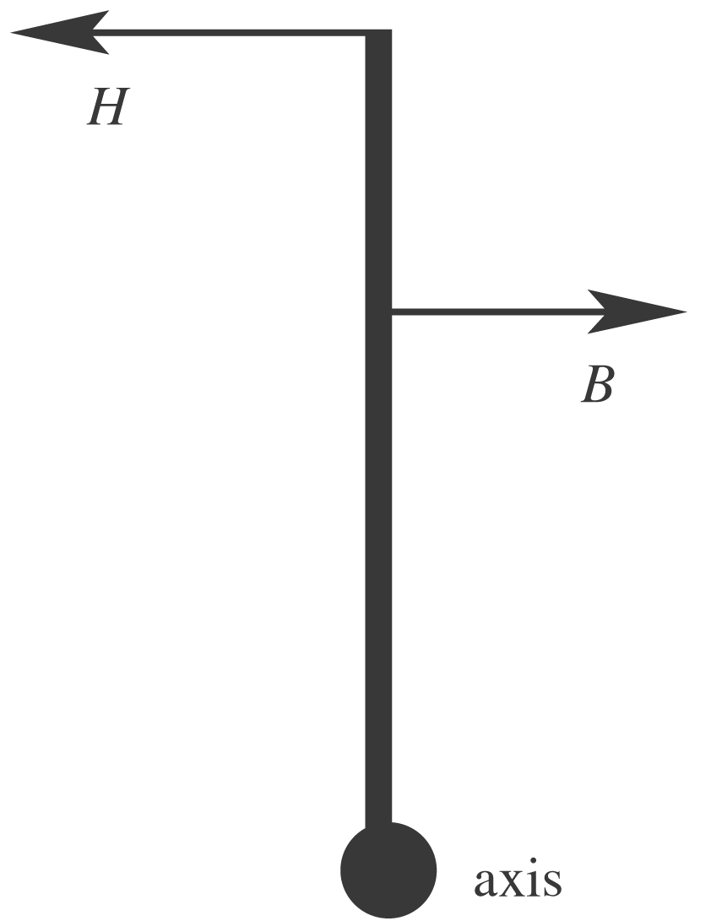

Consider the torques
on one of the walls.

H is the horizontal force exerted by the roof, as considered in part (a). B is the horizontal force exerted by the buttress. Now the angle is 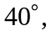so 